**PART B :**

**USE CASE: Design an application for Simulating Random Rolling Dice Using NumPy**

The Dice Roll Simulation may be performed by selecting a random number between 1 and 6, which we can achieve using the random package in Python. we'll show you how to make a Dice Roll Simulator using NumPy

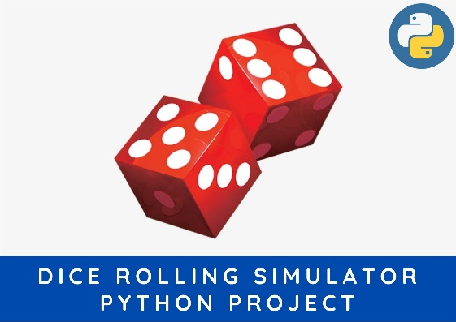

**Game Rules:**

Player will throw a dice and the output will be added to the current scores of the player (initially equal to zero). If the dice had output 6 then it would be thrown again (one dice: 6, one more turn: 4. Then the total would be 6+4 = 10). The sum of total will be throwing id the total score of the player with a particular number of trials.

**The formal code structure is as:**

player() class: This player class will be storing player name, its age and its color code for the game. There is a method called score which stores the attribute score associated with the player. Another method getscore() for calling the value of score stored.

game() class: This class represents the game and take input as the player (class type) and the number of trails. The method __init__() defines the attribute associated with the class type game. The method gaming() is consisting of the whole game.

dice() function: The function dice just give output as a random value from the number set [1,2,3,4,5,6]. This uses random.choice() function for performing this task.

import random

import numpy

def roll():

return random.choice([1,2,3,4,5,6])

class player(object):

def __init__(self, name, age, colour):

self.name = name

self.age = age

self.colour = colour

def score(self, score):

self.score = score

def getscore(self):

return self.score

def getname(self):

return self.name

def __str__(self):

return 'NAME: ' + self.name + '\nCOLOUR: ' + self.colour + '\nSCORE: ' + str(self.score)

class game(object):

def __init__(self, playr, trails):

self.trails = trails

self.playr = playr

def gaming(self):

throw = 0

score = 0

for i in range(self.trails):

throw = roll()

if throw == 6:

throw = throw + roll()

score = throw + score

return score

def __str__(self):

return self.playr.getname() + str(self.score)

tri = 123

zack = player('zack', 24, 'green')

johny = player('johny', 25, 'yellow')

kina = player('kina', 14, 'red')

usher = player('usher', 13, 'blue')

print("-----------LETs PLAy THIs GAMe--------------\n" )

#zack.score(88)

#print(zack)

zackscr = game(zack, tri)

johnyscr = game(johny, tri)

kinascr = game(kina, tri)

usherscr = game(usher, tri)

scr = []

scr.append(zackscr.gaming())

scr.append(johnyscr.gaming())

scr.append(kinascr.gaming())

scr.append(usherscr.gaming())

scrsort = sorted(scr)

for el in scrsort:

print(el)

zack.score(scr[0])

usher.score(scr[3])

kina.score(scr[2])

johny.score(scr[1])

#players = []

#players.append(zack.getscore())

#players.append(usher.getscore())

#players.append(kina.getscore())

#players.append(johny.getscore())

#for el in players:

# print('--', el)

#print(scr[0])

print(zack, '\n')

print(kina, '\n')

print(johny, '\n')

print(usher, '\n')

**OUTPUT**

**-----------LETs PLAy THIs GAMe--------------**

**485**

**489**

**491**

**525**

**NAME: zack**

**COLOUR: green**

**SCORE: 485**

**NAME: kina**

**COLOUR: red**

**SCORE: 491**

**NAME: johny**

**COLOUR: yellow**

**SCORE: 489**

**NAME: usher**

**COLOUR: blue**

**SCORE: 525**